Lecture 12 –17/01/21

**Spiral Model**

The requirement of Spiral is static in nature.

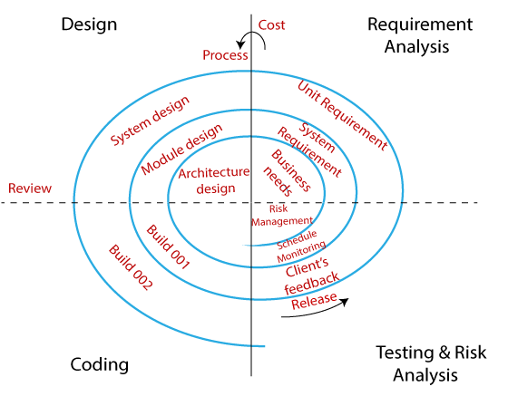

When one phase/Module is working the other phases are idle and this is loss of business.

* Client understands the nature and behaviour of project and no one can understand better than client so client decides what model to be used.
* If the client is not that technically strong then in that case organization decides the model.
* But 95% its client’s decision.
* Many parameters are dependant to decide the model.

Eg.: Budget

**V Model:**

The requirement of V-Model is static in nature.

LCD LCT

Information gathering BRS Test Plan

Requirement analysis Adaptability dev document

Design & coding test case design

Design phase testing

Program phase testing- White box testing

BB testing

Test Execution

Code deployment on QA server System & functional testing

UAT

Test Documentation

Maintenance DRE

CR

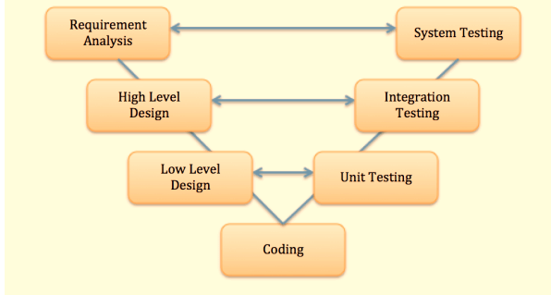

LCD: Life cycle development

LCT: Life Cycle testing

**V Model** is a highly disciplined SDLC model in which there is a testing phase parallel to each development phase. The V model is an extension of the waterfall model in which testing is done on each stage parallel with development in a sequential way. It is known as the Validation or Verification Model.

How WB test comes in LCT?

Client Is least bothered about how it’s done they just need the o/p

V model: modules Runs in parallel

Drawbacks:

Costly

**PET: Process Expert Tools & techniques**

Reformation form of V model

Information gathering Maintenance (sign off)

SRS (Requirement analysis) UAT

HLD System & functional test

Coding Integration test

Unit testing

* Main objective: minimise cost of software
* Developed by HCL and recognized by QA form of India
* In this process organization concentrate on single stage instead of multiple stages

**Waterfall Model:**

BRS

SRS

Design

Coding

Testing

* Waterfall model is a very stricter by nature
* This model is a breakdown of project operations into linear sequential phases
* This means the current stage is purely dependant on delivery of previous stage
* The entry criteria of current state is dependent on exit criteria of previous state
* Waterfall model is a sequential model divided into different phases of software development activity. Each stage is designed for performing the specific activity. Testing phase in waterfall model starts only after implementation of the system is done.

Drawback**:**

* Dependency on previous phase results in the other phases idle
* Costly and preferred by big clients
* Assume we have identified requirement defect that means SRS must be updated and hence design should be modified and then code will be modified till that time testing will be idle

**Agile Model:**

* Agile model is very flexible by nature
* Cumulative approach
* The requirement of agile is dynamic in nature. (Requirement changes constantly)
* It’s not plan driven, it’s value driven (we don’t follow a static plan)
* Frequent changes don’t have impact on testing and development.
* In other models’ Quarterly deliverables: Project is released every 3 months and delivered to the client
* But in Agile Project is released every month and delivered to the customer

BRS SRS Design Coding Testing

Pros:

* We don’t have to wait longer to resolve bugs
* If client modifies or adds requirement then in waterfall model, we ask them to give a new requirement. But in Agile we consider that as a modification in existing requirement and consider as change request (small requirement)
* Similarly, when we find some small defect in production client drafts big penalty in waterfall, but in case of agile client will also be flexible.

Eg: currency code is getting reflected in post fix not in prefix

1,099.00 $

Drawback:

* Dependency on previous phase results in the other phases idle.

Lecture 13 –18/01/21

**RFC**: Request for change

**CR**: Change Request

* Agile is a methodology:
* Agile is a philosophy it’s not plan driven its value driven
* I mean to say that in agile requirement is absolute dynamic in nature.
* That is nothing but frequent changes in the requirement doesn’t have any impact neither on development nor on testing or on production.
* Agile follows cumulative approach.

Every phase runs parallelly

We are using Scrum

Priority of Agile is to satisfy customer by early & continuous delivery of software.

**Various types of Agile:**

Lean

Kanban

Crystal

DSDM: Dynamic system dev

FDD: Development method

XP: Extreme programming

Scrum

Release span of vmodel and waterfall🡪 3 months 🡪 1 Quarter🡪90 days🡪 Quaterly delievery

In agile🡪4 weeks🡪sprint

**Terminologies**:

|  |  |  |
| --- | --- | --- |
| **Agile** | **Vmodel/Waterfall** |  |
| Stake Holders | Stake Holders | PM, DM, SPM |
| Product Owner | Business Analyst | Collects list of requirements |
| Solution Owner | Account Manager | does cost Analysis |
| Product Backlog | Project Requirement |  |
| Sprint Backlogs | Release Requirement |  |
| Scrum Master | Project Manager |  |
| Estimation | Estimation |  |
| stories | SRS |  |
| Acceptance criteria | Use case |  |
| Scrum Meeting | Status call |  |
| Sprint | Release | Product release |

**Architecture of Agile:**

Sprint Backlog Sprint

Solution Owner

Developer

Sprints

Sprints

Stories

Stake Holders PM,DM,SPM

Sprints

Estimation

Sprints

Product Owner WAR Room

Tester

requirements

Sprints

TCS Syntel

India Russia

Sprints

Product Backlog

**Agile Requirement:**

Orders in requirement

**Solution Owner:** Is responsible for cost analysis, generate the revenue and channelize it.

**Stake holders:** PM, DM, SPM

Are responsible for corresponding agile project deliverables.

They are involved in risk analysis, scope descriptions

Defining the scope of the project and technical operations

**Product Owner:**

Is responsible for collecting the project requirements i.e product backlog

Involved in estimation

User stories design and describing the acceptance criteria (Use case)

Collects list of requirements

The requirement is not sequential

BA is responsible for stories designing

1 copy to tester 1 to developer

**Product backlog:**

List of product backlog defines the list of requirements to be developed for the corresponding agile project.

**Estimation:**

We are going to deliver product backlog to sprint backlog

It is a mechanism used for transformation of product backlog to sprint backlog

3 parameters considered to define the estimation:

knowledge

effort-> how much efforts are needed

Complexity-> how much the requirement is complex

Which requirement is impacting how much?

Understanding the important of requirements

**Who all are involved in Estimation?**

In estimation process Product owner, developer and testers are also involved.

Sprint Backlog:

Whenever requirements inserted in sprint

**Sprint Backlog:**

The list of requirements to be delivered in corresponding sprint for the agile project.

**Sprint:**

Sprint defines a release for a module.

Basically, the duration of sprint is 1 month of 4 weeks

**Stories/CRS:**

Basically, the PO is responsible to design the stories.

It is SRS

Stories is basically customer requirement designed wrt the sprint backlog

Functional requirement to be developed and

System requirement to be used.

It consists:

Acceptance criteria: defines the use cases,

defines functionality in terms of i/p o/p & process.

Description

reference

after story creation 1 copy is send to developer and other to tester

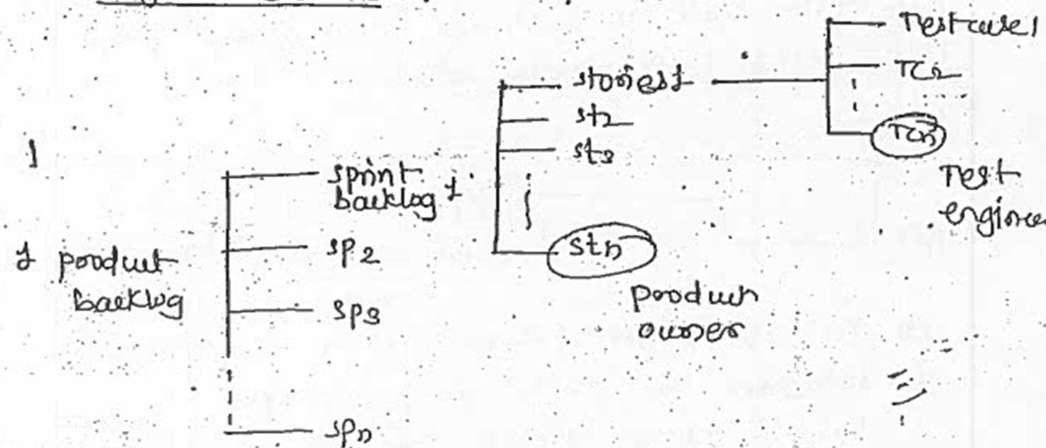

**use case:** business condition

defines functionality in terms of i/p o/p & process.

Eg:

While logging in:

* User should give user_id password
* On clicking submit user details will be validated
* If validation fails:

Error message is displayed, UC ends

* If valid:

User logs in

**Attributes of AGILE**

* Checkpoint after each module
* Scrum meeting
* Implementation of automation
* Sprint wise delivery
* Checkpoint after each module

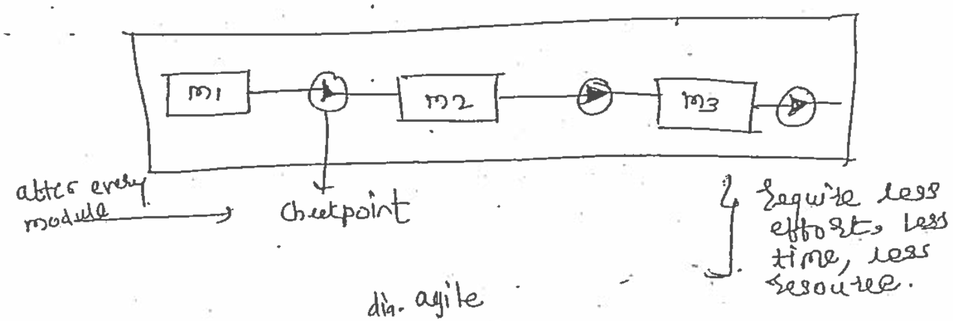

Scrum meeting

Implementation of automation

Avoid human error

Time is saved

Less cost

Sprint wise delivery

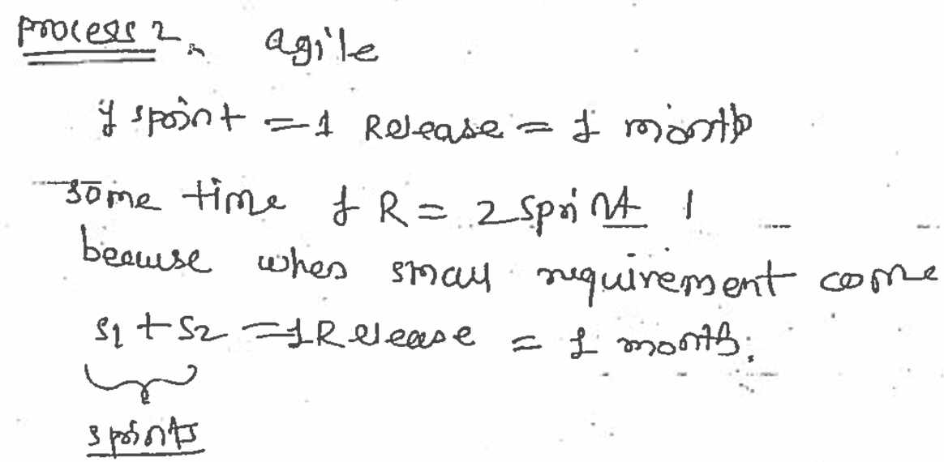

**Meeting Terminologies:**

**Agile Velocity:**

Is a guessing technique is used to determine the total no. of sprint backlog to be delivered for the corresponding agile project?

Note: Generally, in 1 sprint 🡪 7-12 requirements in a sprint backlog (Requirements)

Descope Requirement 🡪

AV/Total no. of sprint backlog in agile project=   
Total no. of sprint backlog in 1st sprint * Total no. of sprint

10*7=70

Let’s assume there are 10 sprint backlogs in 1st sprint

**Agile Grooming:**

This meeting conducted before the start of a sprint by PO and team to analyse the sprint backlogs to be delivered in corresponding sprints.

and analyse whether requirement is clean, or modification is needed

**Burn down Chart:**

Represents the mapping of pending tasks and pending time.

Pending Chart

Effort

**Retrospective meeting:**

It is a meeting conducted after every sprint to analyse the event and output to ensure what went wrong and what actions will be taken to improvise it.

**Scrum Meeting—Daily stand up call**

Chairperson- Scrum Master 🡪organizer of the meeting

Duration: 1hr to 1:30 hr

Evening 5 to 6pm

**Agenda**

What we did?

What we will do next?

What are the road blocks/issues?

Everybody belongs to the project BA + Tester + dev

High Level: overview

Low level: detail description

Onshore team offshore team

**Stories design:**

Designed by PO

Description-End user can download order processing data via pdf.

In this section various information is available: seller info, Billing info, Shipping info

Reference: will have URL’s of sprint backlog

Eg: Sprint 2_sprint backlog_invoice 1_008

**Acceptance criteria:**

1 story 🡪 8/12 acceptance criteria’s

AC001: As an end user I should be able to select invoice in your orders page

AC002: As an end user I should be able to click invoice 1

AC003: As an end user I should be able to download the info via pdf format

AC004: As an end user I should be able to visualise the below info:

seller info, Billing info, Shipping info

AC005: As an end user I should be able to see the data

**Estimation Process:**

Transformation of product backlog into sprint backlog. Done with:

Knowledge:

Complexity: nature of the project

Efforts:

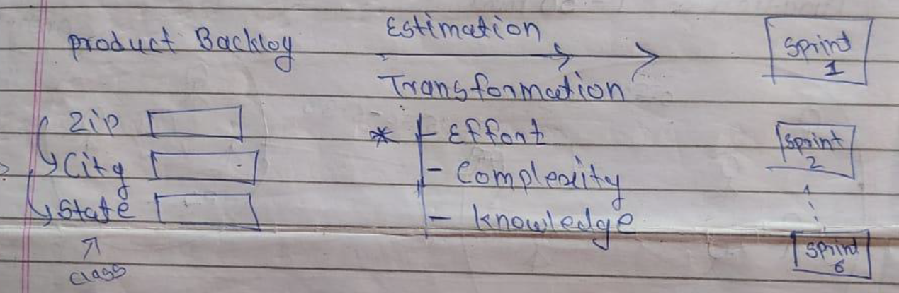

Agile Project:

ETL

Database

Unix

Supply Chain🡪domain

End user has to search the availability of product in specific warehouses(or in specific location)

Project:

Explain objective of the project

Eg: End user wants to search data from db

Data is pulled by applying business logic

System Integration:

Performance tuning: logic for searching and result should be displayed in min time

Product_id Grid

|  |  |  |  |
| --- | --- | --- | --- |
|  |  |  |  |
|  |  |  |  |
|  |  |  | Productid |
|  |  |  |  |

Product_type

Location_id

Date

Export Search business logic: x+y+z

Effort estimation

Data in the front end will be verified with backend

Product id🡪x🡪a🡪today

Agile follows Iterative and regression approach? What does it mean?

Iteration(repetition)

We add new requirement in the existing requirement and repeat the search

Requirements of agile follows iterative approach

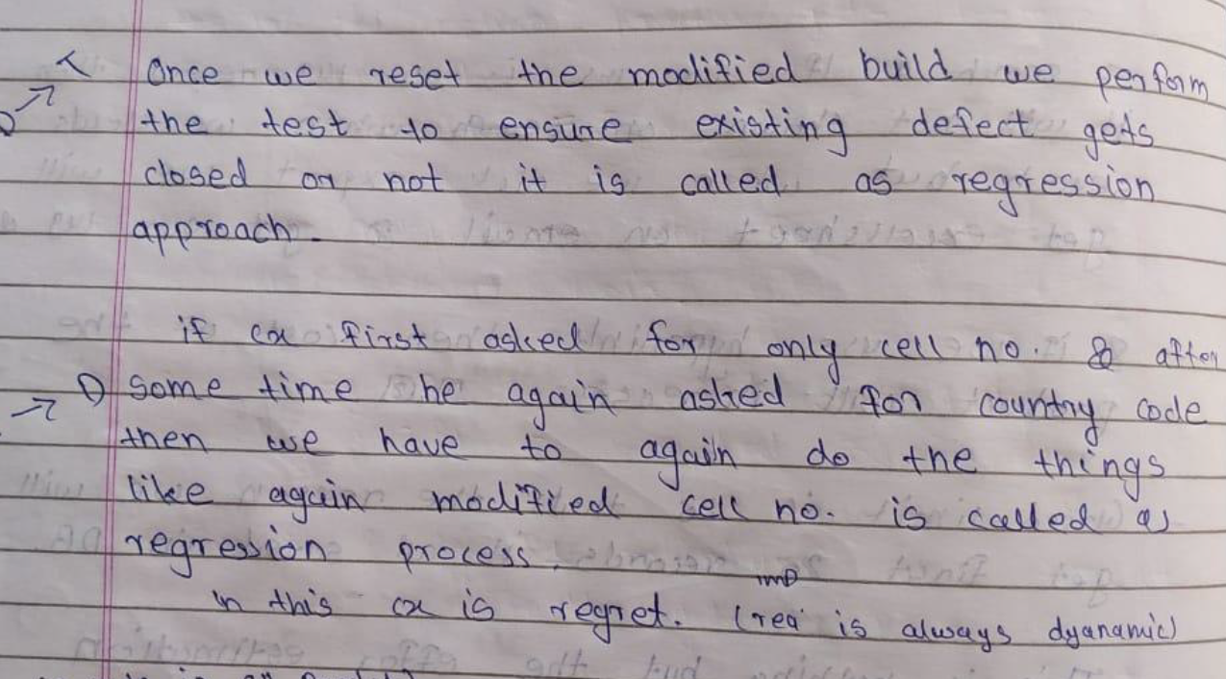

Knowledge and complexity